AI ASSISTED CODING
ASSIGNMENT-6.3
Name: M. Meghana
Hall ticket No: 2303A52505
Batch: 50

Lab 6: AI-Based Code Completion – Classes, Loops, and Conditionals
Lab Objectives
• To explore AI-powered auto-completion features for core Python constructs such as classes,
loops, and conditional statements.
• To analyze how AI tools suggest logic for object-oriented programming and control structures.
• To evaluate the correctness, readability, and completeness of AI-generated Python code.
Week3 -
Wednesday
Lab Outcomes (LOs)
After completing this lab, students will be able to:
• Use AI tools to generate and complete Python class definitions and methods.
• Understand and assess AI-suggested loop constructs for iterative tasks.
• Generate and evaluate conditional statements using AI-driven prompts.
• Critically analyze AI-assisted code for correctness, clarity, and efficiency.
Task Description #1: Classes (Student Class)
Scenario
You are developing a simple student information management module.
Task
• Use an AI tool (GitHub Copilot / Cursor AI / Gemini) to complete a Student class.
• The class should include attributes such as name, roll number, and branch.
• Add a method display_details() to print student information.
• Execute the code and verify the output.
• Analyze the code generated by the AI tool for correctness and clarity.
Expected Output #1
• A Python class with a constructor (__init__) and a display_details() method.
• Sample object creation and output displayed on the console.
• Brief analysis of AI-generated code.
Prompt:
# write a class with method name as display_details to print student information which contains attributes as name,roll number and branch.
Code:
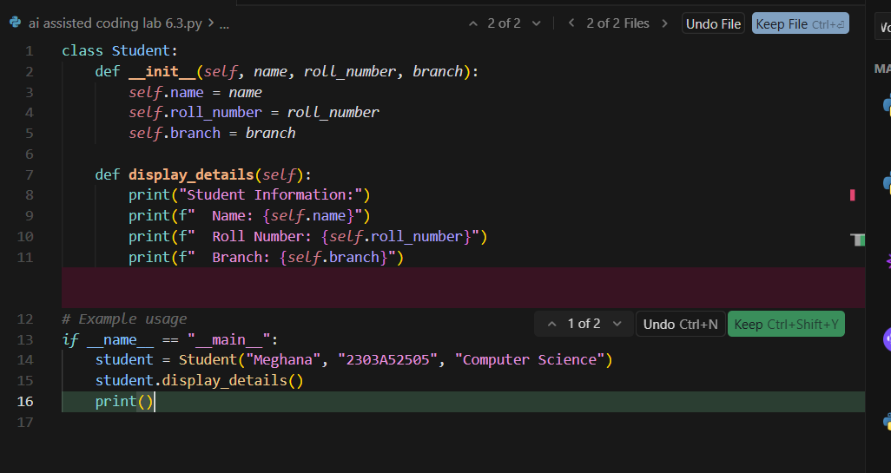
Output:
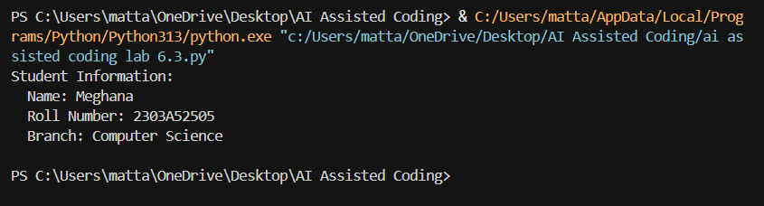
Justification:
The AI-generated Student class is simple and correctly uses a constructor to store student details. The display_details() method neatly prints the information, making the code easy to understand and well-structured.

Task Description #2: Loops (Multiples of a Number)
Scenario
You are writing a utility function to display multiples of a given number.
Task
• Prompt the AI tool to generate a function that prints the first 10 multiples of a given number
using a loop.
• Analyze the generated loop logic.
• Ask the AI to generate the same functionality using another controlled looping structure (e.g.,
while instead of for).
Expected Output #2
• Correct loop-based Python implementation.
• Output showing the first 10 multiples of a number.
• Comparison and analysis of different looping approaches.
Prompt:
# write a code to print first 10 multiples of a given number using 2 different looping conditions and comparison table
Code:
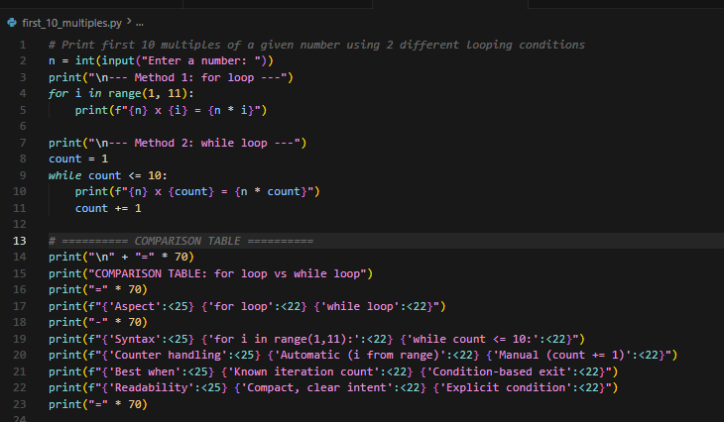
Output:
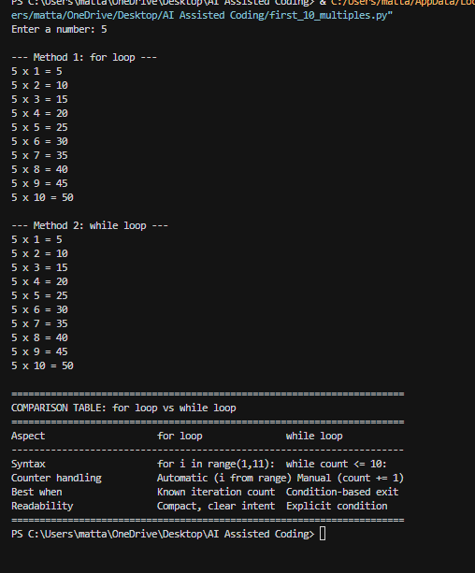
Justification:
The AI correctly generated both for and while loop solutions to print multiples. The for loop is more concise for fixed iterations, while the while loop shows manual control, helping compare both approaches.

Task Description #3: Conditional Statements (Age Classification)
Scenario
You are building a basic classification system based on age.
Task
• Ask the AI tool to generate nested if-elif-else conditional statements to classify age groups
(e.g., child, teenager, adult, senior).
• Analyze the generated conditions and logic.
• Ask the AI to generate the same classification using alternative conditional structures (e.g.,
simplified conditions or dictionary-based logic).
Expected Output #3
• A Python function that classifies age into appropriate groups.
• Clear and correct conditional logic.
• Explanation of how the conditions work.
Prompt:
# generate a code nested if-elif-else conditional statements to classify age groups and another code using different method and give comparsion table for both
Code:
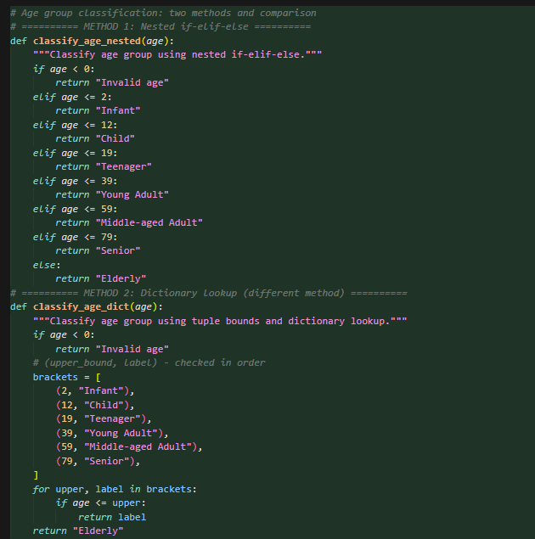
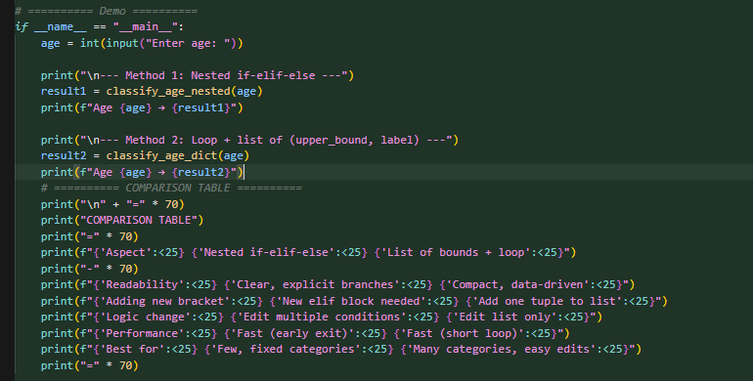
Output:
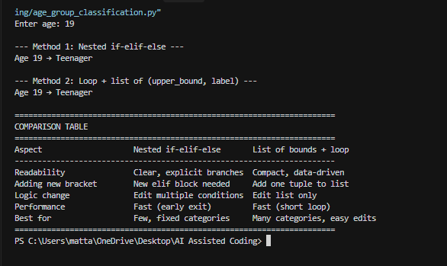
Justification:
The AI-generated conditional statements properly classify age groups with clear logic. The alternative dictionary-based method is more flexible and useful when handling larger categories, making both implementations effective.

Task Description #4: For and While Loops (Sum of First n Numbers)
Scenario
You need to calculate the sum of the first n natural numbers.
Task
• Use AI assistance to generate a sum_to_n() function using a for loop.
• Analyze the generated code.
• Ask the AI to suggest an alternative implementation using a while loop or a mathematical
formula.
Expected Output #4
• Python function to compute the sum of first n numbers.
• Correct output for sample inputs.
• Explanation and comparison of different approaches.
Prompt:
# write a code to generate a sum_to_n() to find sum of first n numbers usinf for loop and another approach and give explanation and comparison of different approaches
Code:
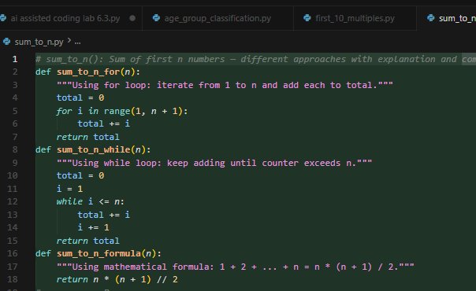
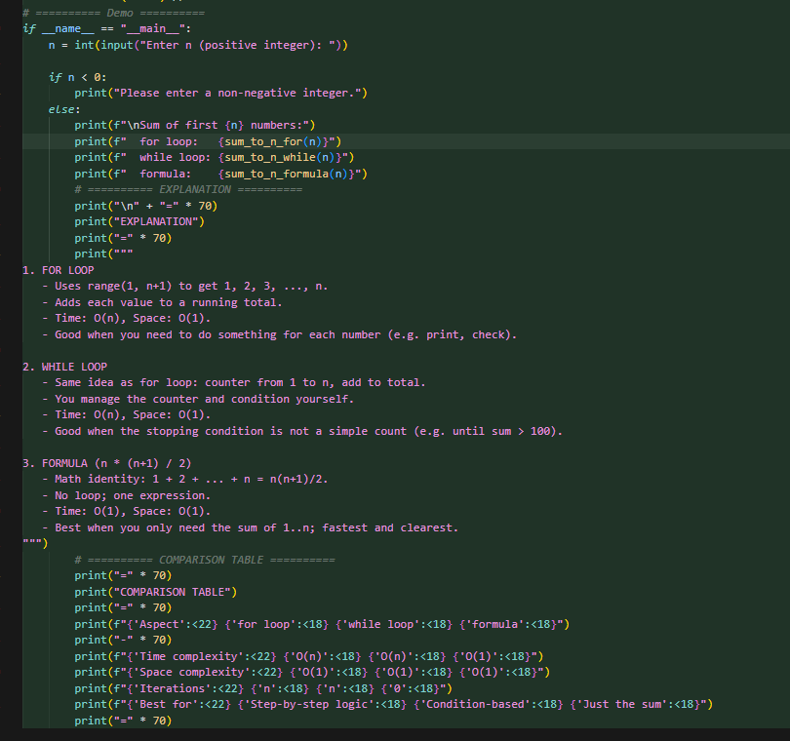
Output:
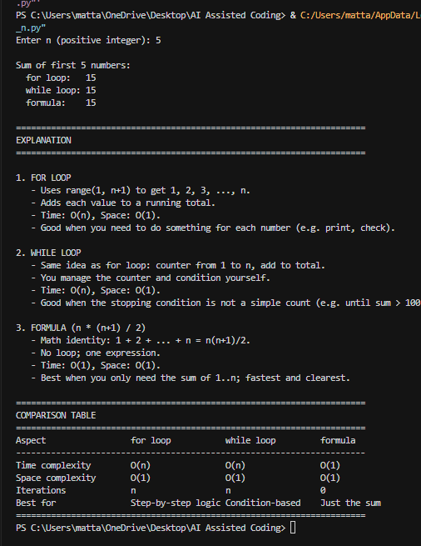
Justification:
The AI provided both loop-based and formula-based solutions correctly. The loop method is helpful for learning iteration, while the mathematical formula is faster and more efficient for direct computation.

Task Description #5: Classes (Bank Account Class)
Scenario
You are designing a basic banking application.
Task
• Use AI tools to generate a Bank Account class with methods such as deposit(), withdraw(),
and check_balance().
• Analyze the AI-generated class structure and logic.
• Add meaningful comments and explain the working of the code.
Expected Output #5
• Complete Python Bank Account class.
• Demonstration of deposit and withdrawal operations with updated balance.
• Well-commented code with a clear explanation.
Prompt:
# write a code with class methods as deposit(),withdraw(), and check_balance() add meaningful comments and explain working of code
Code:
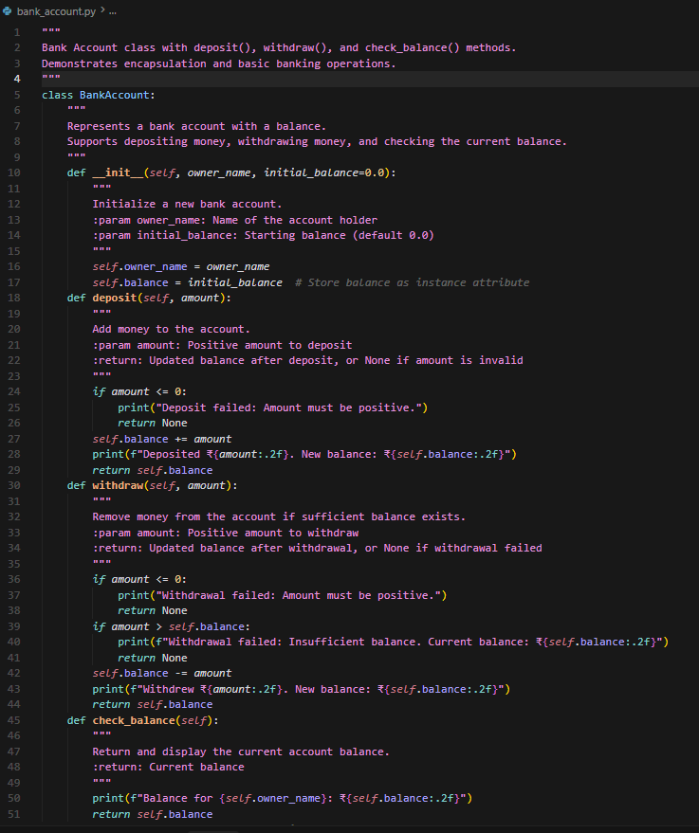
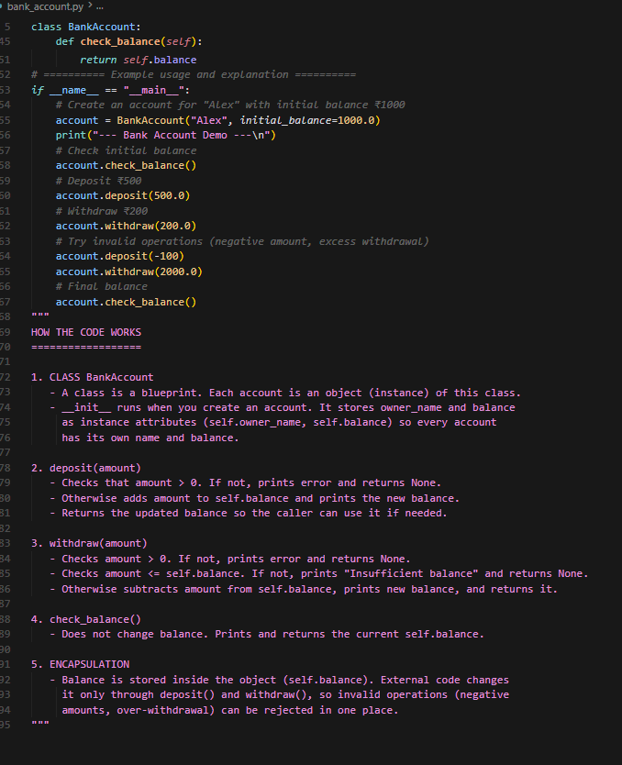
Output:
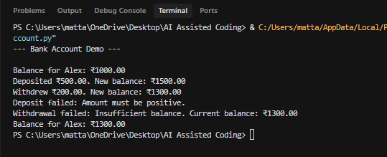
Justification:
The AI-generated Bank Account class correctly includes deposit, withdraw, and balance-check methods. It demonstrates real-world object-oriented programming with proper balance updates and basic validation.

